**Distributed Systems**

Lab 6

Chandy Lamport Global Snapshot Algorithm

S Abhishek

AM.EN.U4CSE19147

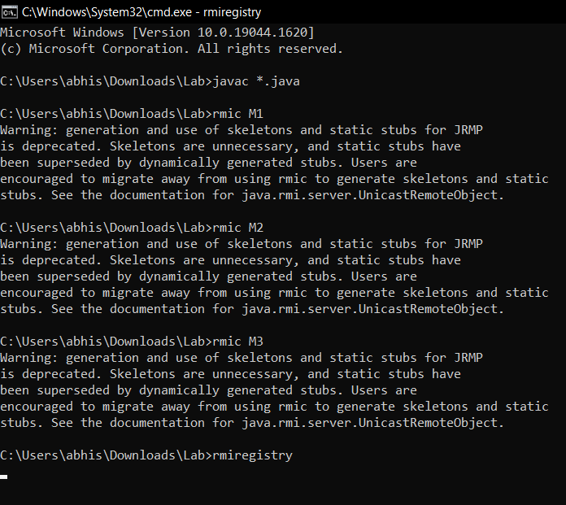

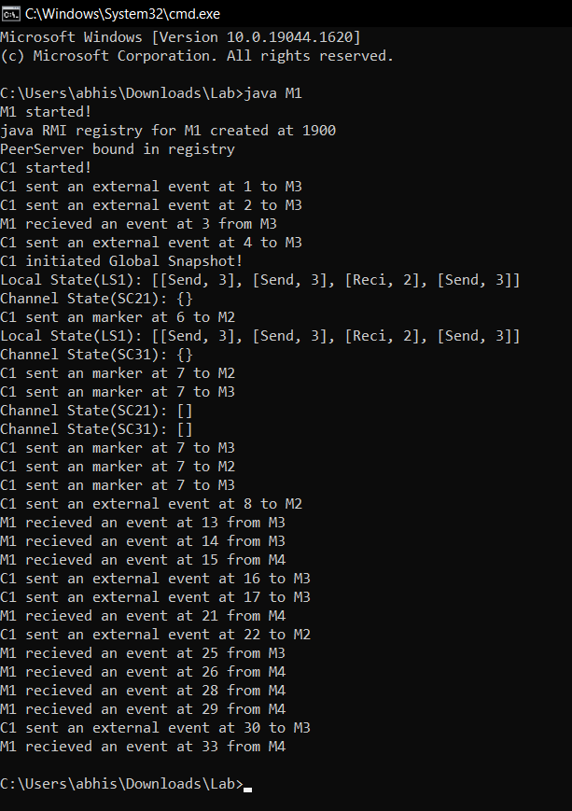

s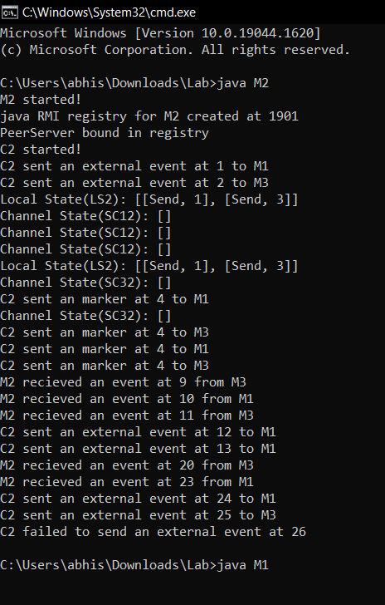

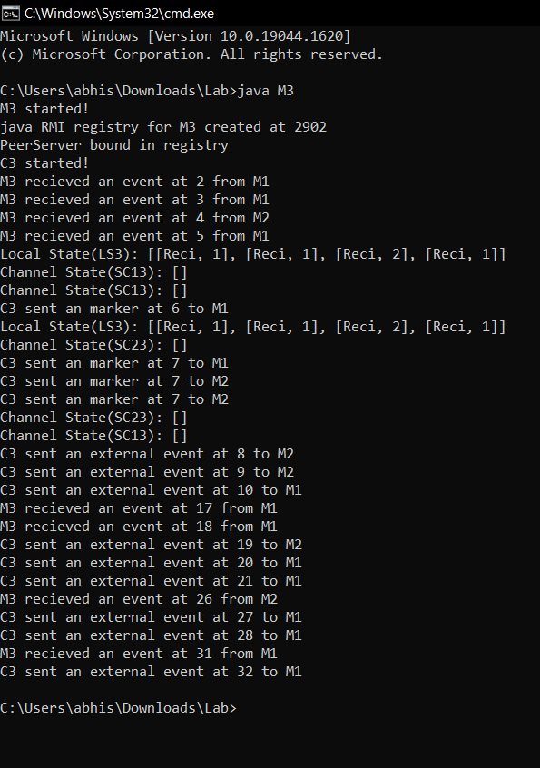

Thankyou!!